Read to Self

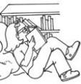

Read to Self



Read to Self

