Write with Teacher

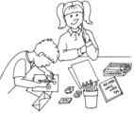

Write with Teacher



Write with Teacher

